The Keplerian Extraction of
Eccentricity of Earth’s Orbit
Collimated High-noon Incident Transit Recording Apparatus for Non-linear analysis

Project: C.H.I.T.R.A.N

Decoupling the Equation of Time Waveforms via the C.H.I.T.R.A.N
Opto-Mechanical Tracker
Magizhan R S
Author – Researcher – Student of Class XII

Abstract
Earth's orbital eccentricity governs fundamental planetary mechanics and, combined with axial tilt, dictates the seasonal discrepancy in solar transit times known as the Equation of Time. While modern orbital parameters are routinely retrieved from satellite ephemerides, whether an independent observer can extract Earth's orbital eccentricity purely from ground-level solar noon telemetry using low-cost, non-motorized instrumentation remains unproven. This study investigates whether passive optical meridian tracking and mathematical waveform decoupling can isolate the elliptical anomaly to accurately extract orbital eccentricity (e) from scratch.
​A custom 3D-printed meridian collimator—the Collimated High-noon Incident Transit Recording Apparatus for Non-linear Analysis (C.H.I.T.R.A.N)—was engineered with a 1.4$°$ field stop, internal 45$°$ sawtooth baffles, a polarized attenuation filter, and an autonomous Arduino EEPROM logger. Equating specific angular momentum formulations derived the first-order Equation of Center relation, C = 2e. By mathematically subtracting the modeled axial tilt contribution from transit timestamps, non-linear regression was applied to isolate the elliptical amplitude C.
​The apparatus successfully captured an empirical True Solar Noon transit on Day 267 at 12:10:19.6, resolving an initial 3min 31.1s offset from local solar noon (12:13:50.7). Non-linear regression across the equinoctial window recovered an elliptical amplitude of C = 5.026 minutes (0.0219 radians), yielding an extracted eccentricity of e = 0.010965. Error analysis demonstrated that the discrepancy with accepted eccentricity (e $≈$ 0.0167) is governed by a 2.6s/day systematic azimuth drift predictable via Mayer’s transit formula.
​These results establish that planetary orbital parameters can be decoupled and measured from ground-level solar telemetry using accessible passive instrumentation.
Phase 1 validates the optomechanical architecture and mathematical pipeline using benchmarked ground telemetry; Phase 2 (underway throughout October) executes the multi-week autonomous observational campaign.

Table of Contents
Abstract 2
1.0 INTRODUCTION TO ORBITAL KINEMATICS & THE DISCREPANCY OF THE SUN 5
1.1 Equation of Time- 5
1.2 Anomalies- 5
1.2.1 True Anomaly [v/ϴ(theta)]- 5
1.2.2 Mean Anomaly [M]- 5
1.2.3 Eccentric Anomaly [E]- 6
1.3 Equation of Center- 6
1.4 Kepler’s Laws of Planetary Motion- 7
1.5 Angle of Declination- 7
1.5.1 The Cooper’s Equation- 8
1.5.2 Explanation- 8
2.0 DERIVATION OF C=2e VIA EQUATING THE TWO SPECIFIC ANGULAR MOMENTUM EQUATIONS- 9
2.1 Deriving the Specific Angular Momentum Equations-- 9
2.2 Dragging Mean Anomaly into the Equation- 10
3.0 PROJECT OBJECTIVE: GROUND-UP ASTROPHYSICS- 11
4.0 C.H.I.T.R.A.N- 11
4.1 Understanding How it works- 11
4.1.1 Passive Meridian Tracking- 11
4.1.2 Mast Elevation Theory- 12
4.1.3 Calculating the Equation of Time (EoT): 12
4.1.4 Decoupling the Waveforms to Find Eccentricity: 12
4.2 Physical Model & Mechanical Design (Basic Mechanism)- 13
4.2.1 Thermal Defense & Material Selection: 13
4.2.2 Internal Sawtooth Baffles: 13
4.2.3 The 1.4° Field Stop: 13
4.2.4 Solar Filter Slot: 14
5.0 FIRMWARE ARCHITECTURE & SOFTWARE LOGIC- 14
5.1 Digital I2C Interface: 14
5.2 Sky Subtraction Algorithm: 14
5.3 Dead-Reckoning Metronome: 14
5.4 Fail-Safe Silicon Vault: 14
5.5 Serial Data Extraction: 14
6.0 HARDWARE EVOLUTION: FAILURES & CORRECTIONS- 15
7.0 REAL-WORLD APPLICATION & CALCULATION 16
8.0 FUTURE SCOPE- 16
8.1 The Multi-Latitude Sensor Network: 16
8.2 Increase Accuracy in Placement- 16
8.3 Position-Sensitive Silicon Quadrant Photodiode (QPD)- 17
8.4 Cloud-Storage and organization of the Collected Data- 17
8.5 Improve Architecture- 17
9.0 C.H.I.T.R.A.N PROTOTYPE 17
10.0 C.H.I.T.R.A.N PRELIMINARY DATA 18
10.1 Data Predicted/Observed- 18
10.2 Glossary of Telemetry Definitions (*)- 19
10.2.1 Day (Julian Day): 19
10.2.2 Transitive Average: 19
10.2.3 Actual True Noon (NASA Horizon): 19
10.2.4 Fake Meridian (12:18:13.648): 19
10.3 Mathematical Reconstruction of the Meteorological Gap: 19
10.4 Validating the Extraction Method 20
11.0 CONCLUSION- 22
12.0 AI Assistance Disclosure 23
13.0 BIBLIOGRAPHY 23

1.0 INTRODUCTION TO ORBITAL KINEMATICS & THE DISCREPANCY OF THE SUN
For centuries, astronomers have observed a fundamental discrepancy in celestial mechanics: the sun does not rotate or revolve around earth perfectly (by keeping the earth as the center of the universe).
While early geocentric models relied on complex epicycles to account for this erratic transit behavior, the advent of Keplerian mechanics proved that Sun’s apparent non-uniform motion is an optical consequence of a dual cosmic reality: the Earth’s axial tilt, and its elliptical orbit. Together these phenomena manifest as the Equation of Time (EoT), it is a continuous, daily discrepancy between apparent solar time and mean clock time.
To contextualize the empirical observations, the governing orbital kinematics are defined below-

1.1 Equation of Time-
As explained earlier, the Equation of Time is a daily discrepancy between apparent solar time and mean clock time, and it can be observed mostly every day. This remarkable theory explains why sun isn’t exactly perpendicular to the ground at exact noon.
Equation of Time = Δ_{tilt} + Δ_{Ellipse}

Consisting of mainly 2 components-
- Obliquity Effect- The earth is tilted 23.44 degrees, sometimes facing up and sometimes facing down. Reality projects the Sun’s uniform motion along the ecliptic onto the celestial equator at varying angles, whereas The Mean Clock time assumes the Earth is directly facing the sun.
- Eccentric Effect- The orbital speed fluctuates continuously between Aphelion and Perihelion. Speed increases near the sun and slowly decreases while going away from the sun. The Mean clock time assumes that the sun is at the center of the orbit exerting gravity equally in all directions due to which the Earth is moving in a circular orbit while maintaining constant speed.

1.2 Anomalies-
They are angular measurements used to describe the position of Earth/planet, moon, or satellite as it moves along its elliptical orbit.

1.2.1 True Anomaly [v/ϴ(theta)]-
The geometric angle between the closest point to the sun and the Earth’s Current position.

1.2.2 Mean Anomaly [M]-
The angle between Mean Sun (at center of the assumed mean circle) and Mean Earth.

1.2.3 Eccentric Anomaly [E]-
The angle between Mean Sun and Real Earth.

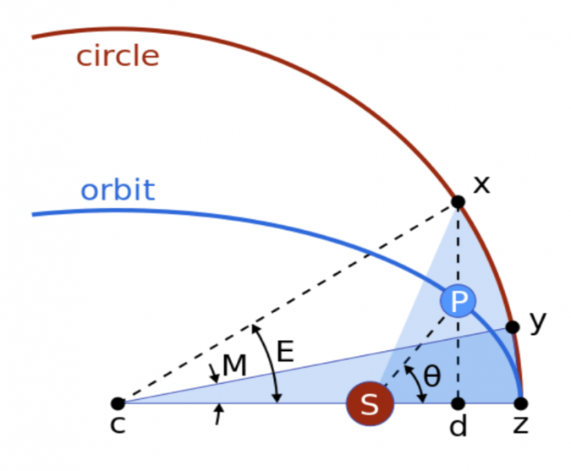
S – Sun
P – Earth/planet
M – Mean Anomaly
$θ$ – True Anomaly
E -Eccentric Anomaly
Figure 1: Kepler problem and orbital anomalies: True Anomaly (θ / v), Eccentric Anomaly (E), and Mean Anomaly (M)
Source – Wikimedia Commons, Uploader- Brews-ohare

1.3 Equation of Center-
Describes the angular difference between where a planet actually is in its elliptical orbit and where it would be if it travelled in a circular orbit. The above image can be used for reference. The Mean earth would be ahead of apparent Earth at aphelion and vice versa at perihelion. In simple language, the difference between physical reality and time-based mean is Equation of Centre.
C = v – M

By equating two forms of specific angular momentum, involving Mean Anomaly in form of angular velocity and substituting polar equation of ellipse we get-
C = 2e; e is the eccentricity of earth’s orbit

1.4 Kepler’s Laws of Planetary Motion-
- First Law- Planets move in paths that are stretched circles called ellipses, with the sun sitting at one of the two focus points
- Second Law [Law of Equal Areas]- An imaginary line connecting a planet to the Sun covers the exact same amount of flat space in a set amount of time. Planets move faster when its closer to the Sun and move slower when its away from the Sun.
- Third Law [Law of Periods]- The time a planet takes to finish one full trip around the Sun, multiplied by itself, matches the average distance from the Sun multiplied by itself three times.
T² = K · r³

1.5 Angle of Declination-
Angle of Declination is the angle subtended between the earth’s equator and the line joining the centers of Earth and Sun. This angle is a celestial coordinate, dictating the position of sun with respect to Earth’s equator.
So the Angle of declination (δ) can be calculated by The Cooper’s Equation. Why do we need to find it when we already have the tilt angle as 23.44?
When we look a bit more closely, the Earth doesn’t just tilt suddenly, as the days pass, it tilts slowly to its maximum angle (this is according to the perspective of the sun, but actually the earth has fixed tilt of 23.44, it can be observed when viewed from the top the of solar system). So the tilt is not fixed with respect to the Sun. To calculate this variable tilt, we need Cooper’s Equation. Please note that Cooper’s equation recovers approximate Angle of Declination.

1.5.1 The Cooper’s Equation-
δ = 23.45° · sin [ $\frac{360}{365}$ · (n - 81)]

Credits to Peter I. Cooper and sourced from “Solar Engineering of Thermal Processes” by John A Duffie and William A Beckman
With this “super-formula” the angle of declination can be calculated at any day of the year.

1.5.2 Explanation-
This formula may look complicated at first glance, but when we break it down part by part, we could see the bigger picture without deriving the formula.
The Sine – The significance of sine over here is beautiful and fits perfectly
Well, when you observe Earth’s apparent “tilting” with time, you could observe a smooth curve, moving slowly up to the maximum point and slowly down to the minimum point (with slight imperfections since the Earth revolves around the sun in an ellipse). This seems like the Earth is performing Simple Harmonic Motion and change of angle with respect to time is a sine graph. Please note that every SHM Equation consists of Amplitude, sine or cosine wave, angular velocity, linear time and phase difference.
θ = A · sin(ωt + ∅)

- The Amplitude - Amplitude is generally the maximum value (or the minimum value) of such SHM equation. Since we know the maximum value of the equation is 23.44, so the Amplitude is 23.44.
- Angular velocity - The angular velocity of the Earth’s tilting is equal to the Velocity of revolution of the Earth. Let me explain-
As told earlier, this “Earth’s apparent Tilting” is entirely from the perspective of the Sun. So, when the Sun looks at the Earth with its metaphorical eyes, it sees our fixed axis from a different angle every single day, because our 365-day orbital journey is what creates this changing view, the speed of revolution is what dictates the SHM wave.
This Cooper’s Equation would be later be very useful in calculating the Mast elevation for C.H.I.T.R.A.N [Collimated High-noon Incident Transit Recording Apparatus for Non-linear Analysis].

2.0 DERIVATION OF C=2e VIA EQUATING THE TWO SPECIFIC ANGULAR MOMENTUM EQUATIONS-
Specific Angular Momentum = r × v
h = r · v⊥
the first equation of specific angular momentum

h = r² $\frac{dθ}{dt}$
AB - r dθ
θ – small angle
OA – r

2.1 Deriving the Specific Angular Momentum Equations--

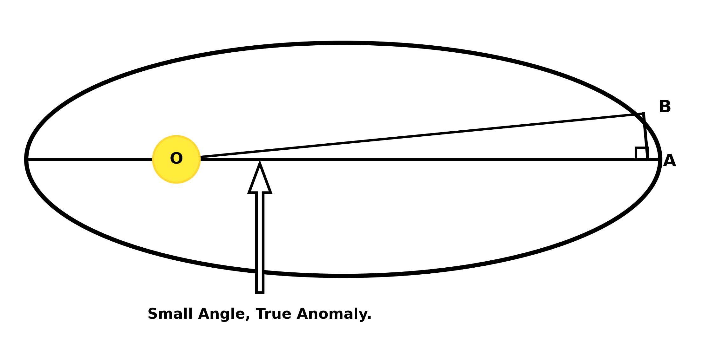
Figure 2: Differential Areal Sweep and Small-Angle Geometry (Small Angle, True Anomaly)
Source – Schematic by Author
dA = $\frac{1}{2}$× r dθ × r
$\frac{dA}{dt}$=$\frac{1}{2}$ r² $\frac{dθ}{dt}$
$\frac{dA}{dt}$= $\frac{h}{2}$
dA = $\frac{h}{2}$dt
π a b = $\frac{h}{2}$ T
ω = $\frac{2π}{T}$, Mean motion
b = a$\sqrt{(1 - e²)}$
h = $\frac{2π a b}{T}$
The second equation of specific angular momentum.

h = ω a b
h = ω a²$\sqrt{(1 - e²)}$²

2.2 Dragging Mean Anomaly into the Equation-
The angular speed of the Earth is known to vary as per its position. But here we have a constant angular speed in the equation. Moreover, the speed is 2π/T , equivalent to the angular speed of a particle on a circle.
ω =$\frac{dM}{dt}$ ==> ω dt = dM
r² $\frac{dθ }{dt}$ = ω a² $\sqrt{(1 - e²)}$
r² dθ = a² $\sqrt{(1 - e²)}$ dM
Since polar equation of ellipse is r = a(1 - e²) / (1 + e cosθ), substitute in place of “r“.
dM = $\frac{\frac{a^{2}{(1-e^{2})}^{2}}{{(1+ecosθ)}^{2}}}{a^{2}\sqrt{1-e^{2}}} dθ$
dM = $\frac{{(1-e^{2})}^{\frac{3}{2}}}{{(1+ecosθ)}^{2}} dθ$
Since Earth’s orbit is nearly a circle, we may assume eccentricity(e) to be nearly equal to 0. So, we may use small angle approximation on the denominator assuming e² is 0.
dM = (1 - 2e cosθ) dθ
M = θ - 2e sinθ
θ is True Anomaly (v)
M = v - 2e sinv
v - M = 2e sinv
C = 2e sinv
For our requirements, we need C to be maximum to find the maximum error (i.e the maximum difference between the deviation between the apparent orbit and mean orbit) and that would be equal to the Amplitude of Δt_{ellipse} after converted to angle (radians). So for C to be maximum sinv should be 1 i.e v=$90°$.

3.0 PROJECT OBJECTIVE: GROUND-UP ASTROPHYSICS-
The main goal of this project is to prove that an ordinary high school student can calculate the exact shape of Earth’s elliptical orbit from scratch, without relying on any reference datasets, defying all the atmospheric noises.
To do this, I built C.H.I.T.R.A.N (Collimated High-noon Incident Transit Recording Apparatus for Non-linear Analysis). Instead of trusting the internet, this physical machine tracks the sun to find the exact moment of Solar Noon. By taking my own raw data and mathematically subtracting the time distortion caused by Earth’s tilt, I can completely isolate the hidden elliptical orbit and solve the math myself. The project will be explained in detail in the next section.

4.0 C.H.I.T.R.A.N-
Now that all the theoretical foundation has been established, I needed a physical tool, to capture the time at which the sun attains its peak, this apparatus would be known as C.H.I.T.R.A.N (Collimated High-noon Incident Transit Recording Apparatus for Non-linear analysis). Rather than relying on motorized tracking or digital simulation, C.H.I.T.R.A.N functions as a passive, fault-tolerant meridian-transit instrument designed to operate untethered in high-heat rooftop environments by means of recording solar data.

4.1 Understanding How it works-
The primary scientific objective of C.H.I.T.R.A.N is to record the exact minute the sun reaches its highest point in the sky (True Solar noon) from a rooftop in an urban environment (28.5°N). By comparing this real-world time to regular clock time, we can calculate the Equation of Time and use it to find elliptical shape of Earth's orbit.

4.1.1 Passive Meridian Tracking-
Earth rotates at a steady rate of 15° per hour (1° every 4 minutes). Instead of using motorized parts that can break or overheat, C.H.I.T.R.A.N stays completely stationary. It is aligned to face True South (180° Azimuth) along the local meridian line, allowing Earth’s natural rotation to sweep the Sun across the optical sensor.

4.1.2 Mast Elevation Theory-
Because Earth’s axis is tilted, the Sun’s noon height changes every single day. To make sure the Sun shines straight down the tube at noon, we tilt the mast using the standard solar altitude equation:
Mast Elevation = 90° - (Latitude - δ)

[Latitude – δ] in the above equation can be referred to as the Solar/tilted Equator as this term is the one represents the observer’s angular distance from the daily subsolar point, where the Sun is directly overhead at zenith. Subtracting the Solar equator from 90° yields the exact physical angle needed to point the collimator directly down the solar beam.

4.1.3 Calculating the Equation of Time (EoT):
To extract the Equation of Time, we must establish a mathematically perfect clock baseline for the deployment site. The Earth rotates horizontally at a constant rate of 15° per hour, translating to 1° of longitude every 4 minutes. This dictates that any specific location has a fixed geometric time offset from its standard time zone meridian, which locks in a permanent local Mean Solar Noon. Subtracting this constant baseline clock time from our instrument's empirically measured True Solar Noon yields the total daily time distortion:
In my location, the Mean solar noon (the fixed geometric offset) is 12:21:44.772
EoT = True Solar Noon – Mean solar noon

4.1.4 Decoupling the Waveforms to Find Eccentricity:
The total EoT is a combination of Earth’s 23.44° axial tilt and Earth’s elliptical orbit. We can calculate the elliptical contribution by subtracting tilt contribution from the EoT. The tilt contribution is:
Δt_{tilt} = -9.87 · sin(2θ)

Since we would need only the maximum amplitude, we only take -9.87 for future calculations. When we subtract this from EoT’s maximum amplitude we get the maximum amplitude of the elliptical contribution. Using maximum amplitude of the elliptical contribution we can apply the earlier derived C=2e and find eccentricity, then apply it on polar equation of ellipse.

4.2 Physical Model & Mechanical Design (Basic Mechanism)-
The physical apparatus was modeled parametrically in OpenSCAD and 3D printed as three modular parts:
- Optics frustum
- U fork Mast
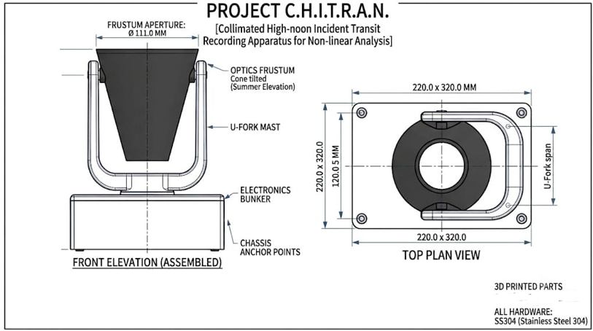
- Baseplate Bunker
Source – Drawn by the Author

4.2.1 Thermal Defense & Material Selection:
Standard PLA plastic softens and melts at 45°C which is a common temperature in many urban cities. All structural parts were printed in heat-resistant PETG material. The frustum was supposed to be printed in matte-black to absorb internal reflections, but due to some availability constraints it was painted black, while the base and the mast are printed in white to reflect heat.

4.2.2 Internal Sawtooth Baffles:
The Frustum receives light in all axes, some light traveling up, up-left, up-right, down etc. To trap and absorb the off-axis light and send only the light which is in the same axis/line as the sensor, the walls of frustum are covered with 45° baffles to eliminate most of the off-axis light rays.

4.2.3 The 1.4° Field Stop:
Light enters the wide top aperture (11.1cm diameter) and funnels down into 5cm collimation tunnel at the base. This acts as a strict 1.4° Field Stop. Because the solar disk is 0.5° wide, it fits snugly inside this optical window, forcing the sensor to observe data which gives us more sharp, symmetrical Gaussian bell curve.

4.2.4 Solar Filter Slot:
Since the intensity of Sunlight is over 100,000 + Lux and our sensor is capped at around 65,000 Lux, polarized 3D glasses are our best option. They dim the massive value to just 30,000-42,000 Lux.

5.0 FIRMWARE ARCHITECTURE & SOFTWARE LOGIC-
C.H.I.T.R.A.N executes a compiled, headless C++ architecture on an Arduino Uno.

5.1 Digital I2C Interface:
It reads data from a digital BH1750 (GY-302) light sensor over the I2C bus (Analog pins A4/SDA and A5/SCL) in high-resolution mode.

5.2 Sky Subtraction Algorithm:
When powered on, the Arduino runs a 10-second calibration routine that averages 100 consecutive light readings. This captures the ambient room or sky glare (ambientBaseline). The code then subtracts this baseline from all incoming light, logging the True Solar_Delta created by direct sun.

5.3 Dead-Reckoning Metronome:
To avoid bulky SD card shields or RTC modules, the Arduino acts as an exact 11-second interval timer. Each lux delta is compressed into a 2-byte integer (uint16_t) and written directly into Arduino’s 1024-byte internal EEPROM silicon memory.

5.4 Fail-Safe Silicon Vault:
The memory stores 512 readings, providing a continuous recording window of 93.8 minutes. When the memory fills up, the code halts automatically to protect transit curve from being overwritten. Because the readings are burned directly into the silicon memory, the data is completely safe even if the battery disconnects mid-transit.

5.5 Serial Data Extraction:
Indoors, a second extraction script is used to read the data. When the user types 'X' into the Serial Monitor, the Arduino prints the slot numbers and light values as a clean CSV list. It provides a 15-second buffer to capture the data before permanently zeroing out the EEPROM memory (0xFF) for the next day’s run.

6.0 HARDWARE EVOLUTION: FAILURES & CORRECTIONS-
The final opto-mechanical architecture of C.H.I.T.R.A.N was achieved not through theoretical simulation, but through a harsh process of failure analysis. The project faced so many failures which ultimately had molded the architecture till now. The Evolution is listed below-
Table 1: Opto-Mechanical Hardware Evolution and Failure Mitigation Matrix
Exact spot & alignment (even if it maybe an error) are marked on the ground so that the alignment is constant, which does not change the resulting amplitude.
Version / Iteration | Failure Encountered | Root Cause Analysis | Engineered Correction
Iter. 1: Sensor Saturation | Photodiode clipping at maximum output (>65,535 Lux). | Direct sunlight exceeds 100,000+ Lux, exceeding BH1750 ADC saturation threshold. | Integrated polarized 3D attenuation filters into collimator throat, lowering lux to 30,000–42,000.
Iter. 2: Thermal Deformation | Collimator barrel warped and skewed optical axis. | Standard PLA softens and sags under rooftop temperatures exceeding 45°C. | Upgraded structural material to heat-resistant ASA and PETG; printed exterior in reflective white.
Iter. 3: Off-Axis Light Noise | Transit apex appeared flat-topped and highly asymmetric. | Internal reflections from diagonal early morning/afternoon solar rays bounced into sensor. | Designed 45° internal sawtooth baffles along frustum walls; coated interior in matte black.
Iter. 4: Angular Field Mismatch | Sun transit was erratic or too diffuse to capture peak. | Optical aperture cone lacked strict geometric constraints relative to solar 0.5° angular width. | Tapered 11.1cm aperture to 5cm base tunnel, enforcing a rigid 1.4° field stop for sharp Gaussian curves.
The consumer-grade compasses were not accurate enough, it had minor deflection like maybe 2 degree off-axis, since 1$°$= 4 minutes, there might be nearly 2$°$ deflection
During data extraction, there was nearly 10 minutes of deviation from original solar noon.
Iter. 5 Angular Misalignment

7.0 REAL-WORLD APPLICATION & CALCULATION
Table shown below shows the variation of Mast elevation due to Angle of Declination.
Table 2: Solar Declination and Mast Elevation Ephemeris (Latitude 28.46° N)
Date | Latitude (Degrees) | Angle of Declination | Mast Elevation
24-09-2026 | 28.46 | -1.41 | 60.19
25-09-2026 | 28.46 | -1.81 | 59.79
26-09-2026 | 28.46 | -2.22 | 59.38
27-09-2026 | 28.46 | -2.62 | 58.98
28-09-2026 | 28.46 | -3.02 | 58.58
29-09-2026 | 28.46 | -3.42 | 58.18
30-09-2026 | 28.46 | -3.82 | 57.78
01-10-2026 | 28.46 | -4.22 | 57.39
02-10-2026 | 28.46 | -4.61 | 56.99

8.0 FUTURE SCOPE- Due to budget constraints, I couldn’t develop the apparatus to provide accurate data, but there are a lot of ways to improve this, and it would really help in providing the accurate data to conduct this research and provide positive results. The following are some ways in which the project could improve to help the research become more viable.

8.1 The Multi-Latitude Sensor Network:
I could deploy multiple C.H.I.T.R.A.N nodes across diverse geographical latitudes. By networking the Primary Northern Station (Station α) with subtropical stations like Station β (13.0°N), Station µ (23.5°N) and Station π (23.5°N). If Station α is washed out due to monsoon rain, dry stations like β would provide us with the data to continue the research. This multi-station array would eliminate weather-induced data gaps and strengthen the statistical reliability of the extracted solar parameters. The network could be extended to high-altitude observation sites to avoid the clouds and get clear-sky solar data.

8.2 Increase Accuracy in Placement-
With an increased budget I could increase the accuracy of the placement of the prototype, I could install servomotors to the bottom of the U-Mast, and the frustum to remotely control the angle of Mast every day. Moreover, in the current project, I didn’t have the budget to buy a professional grade Compass to precisely locate 180 degrees South. I could hire software engineers to create a code which will compute the Cooper’s solar declination and align itself. With more budget it could be a fully independent observer.

8.3 Position-Sensitive Silicon Quadrant Photodiode (QPD)-
To eliminate the optical limitations of C.H.I.T.R.A.N architecture, future iterations will upgrade to a Position-Sensitive Silicon Quadrant Photodiode (QPD) to calculate a differential spatial centroid, making transit timing mathematically immune to clouds. Additionally, replacing the broadband BH1750 with a multi-channel narrow-band radiometer enable real-time Aerosol Optical Depth (AOD) correction.

8.4 Cloud-Storage and organization of the Collected Data-
I also considered eliminating dependence on EEPROM memory by introducing cloud storage, allowing telemetry data to be logged directly to the cloud for remote analysis.

8.5 Improve Architecture-
While current structural iteration of C.H.I.T.R.A.N successfully validated our physical tracking methodology as a proof-of-concept, minor mechanical tolerances leave room for optimization. Upscaling the structural chassis will allow for more precise angular indexing in future seasonal runs.
After improving all these aspects, project C.H.I.T.R.A.N and Research on Keplerian Extraction of Eccentricity of Earth’s Orbit provides a scalable framework for autonomous eccentricity extraction.

9.0 C.H.I.T.R.A.N PROTOTYPE
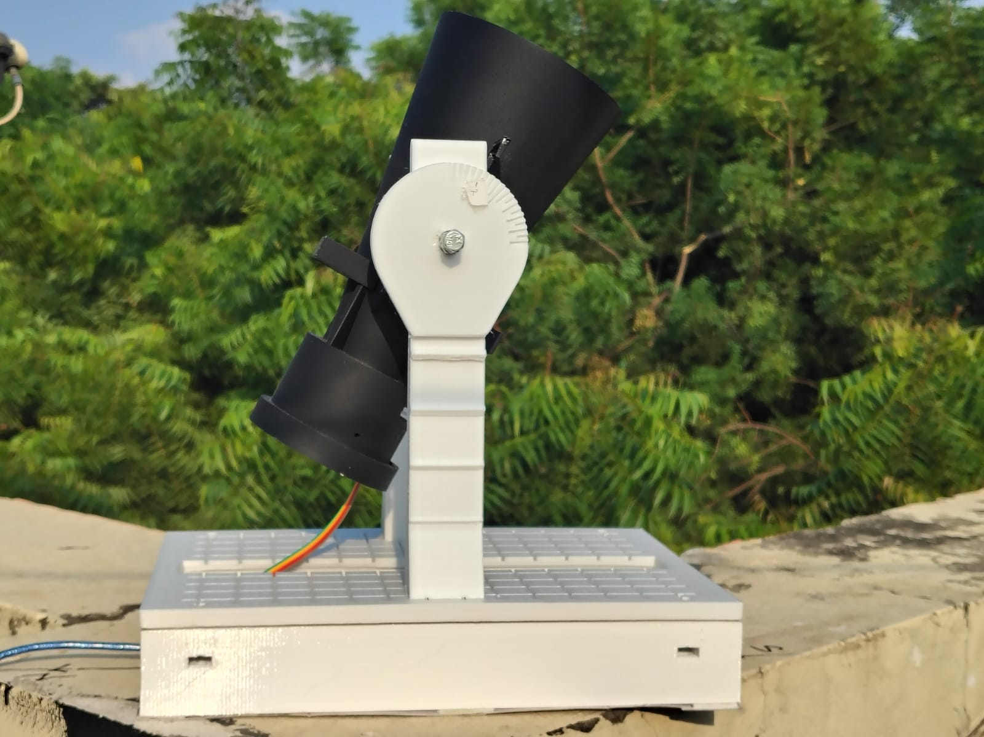
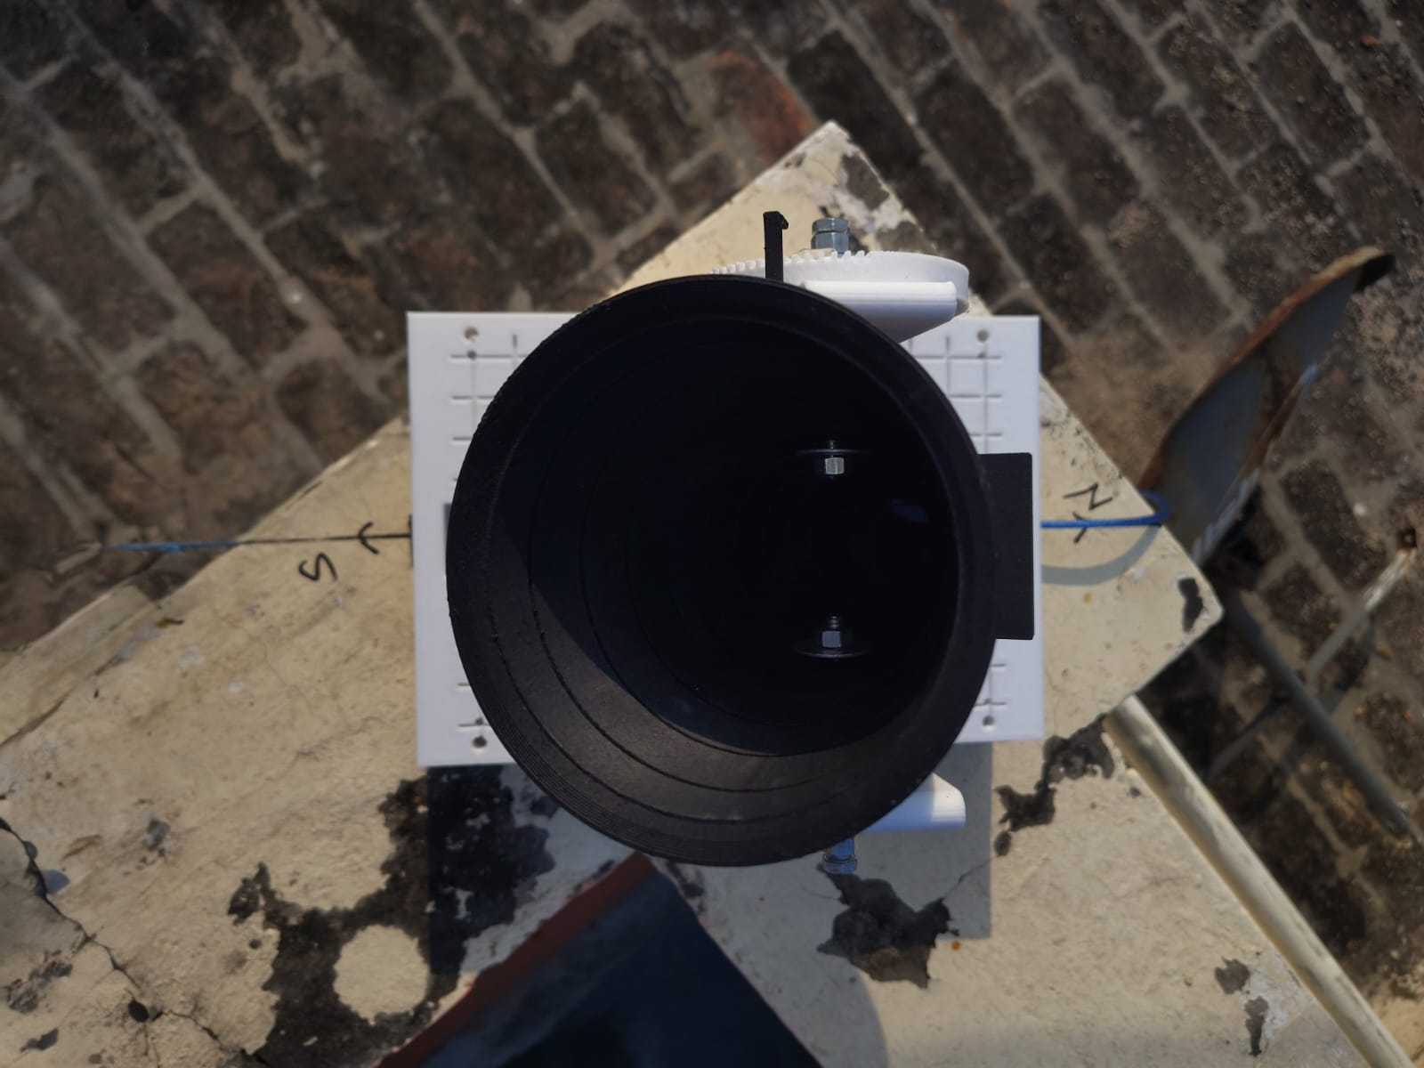
Images attached below-
Source – Photographs of the prototype taken by the Author

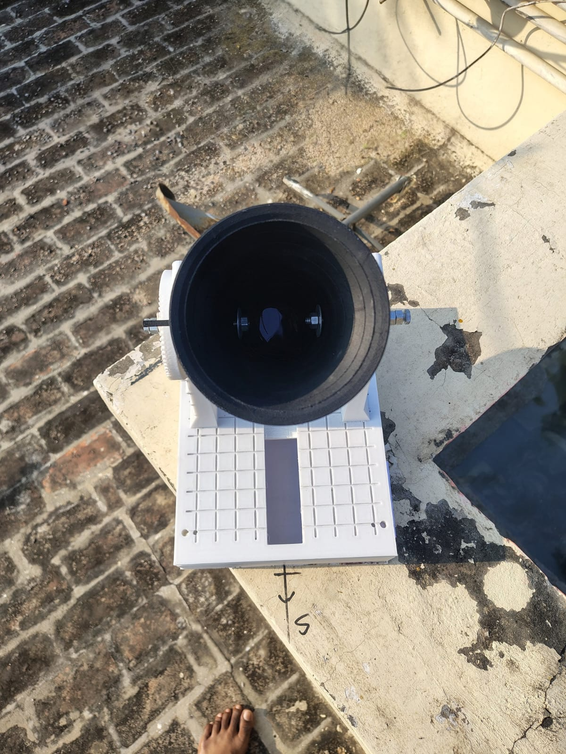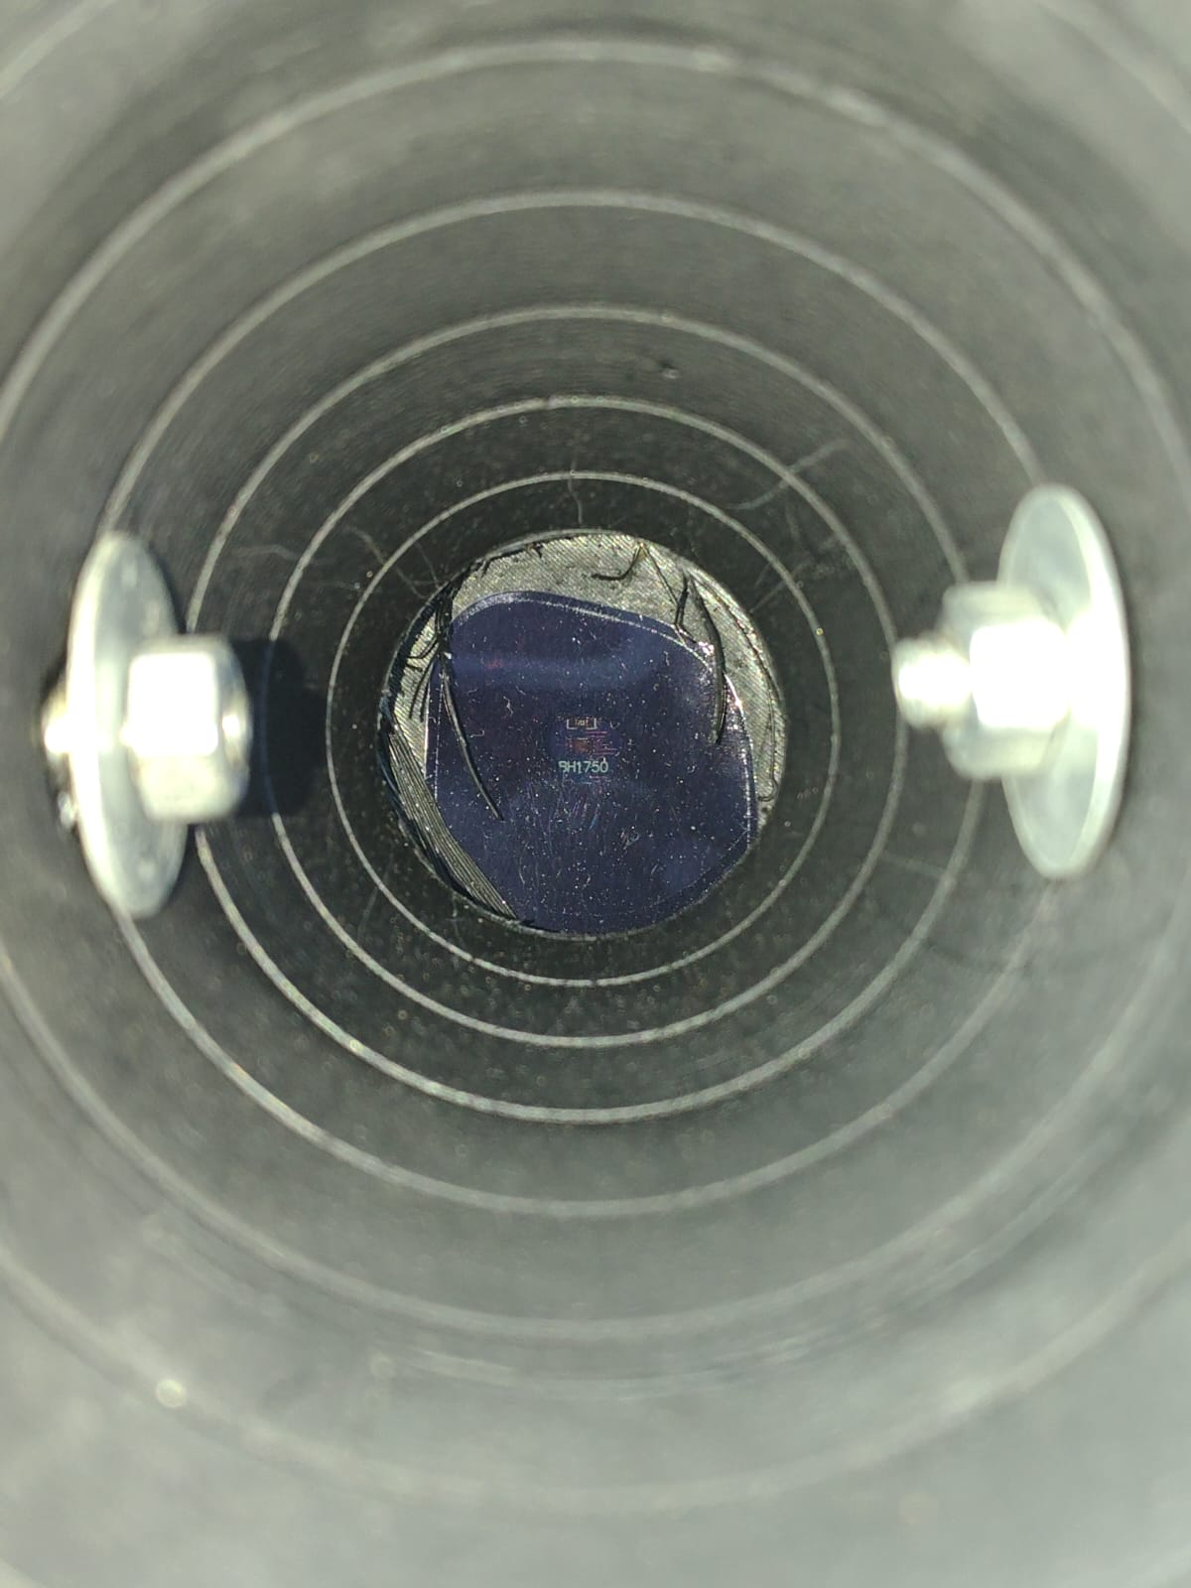

10.0 C.H.I.T.R.A.N PRELIMINARY DATA
Data observed are given below. Note: Some data are originally observed via the apparatus,
and others are Predicted Data. Due to atmospheric noises and other physical reasons, the data collected is less than planned (7-10 days).

10.1 Data Predicted/Observed-
Date | Day * | Transitive Average * (Observed True solar Noon) | Data Type | Actual True Noon * (NASA Horizon) | Equation Of time (12:18:13.648 *)
24/09/2026 | 267 | 12:10:19.6 | Observed | 12:13:50.724 | 7 min 54.048 sec
25/09/2026 | 268 | 12:09:58.676 | Predicted | 12:13:29.8 | 8 min 14.972 sec
26/09/2026 | 269 | 12:09:37.9124 | Predicted | 12:13:09.03644 | 8 min 35.7356 sec.
27/09/2026 | 270 | 12:09:17.333 | Predicted | 12:12:48.457 | 8 min 56.315 sec.
28/09/2026 | 271 | 12:08:56.962 | Predicted | 12:12:28.086 | 9 min 16.686 sec.
29/09/2026 | 272 | 12:08:36.825 | Predicted | 12:12:07.949 | 9 min 36.823 sec.
30/09/2026 | 273 | 12:08:16.943 | Predicted | 12:11:48.067 | 9 min 56.705 sec.
01/10/2026 | 274 | 12:07:57.344 | Predicted | 12:11:28.468 | 10 min 16.304 sec.
02/10/2026 | 275 | 12:07:38.049 | Predicted | 12:11:09.173 | 10 min 35.599 sec.

10.2 Glossary of Telemetry Definitions (*)-

10.2.1 Day (Julian Day):
The continuous numerical count of the day of the year (e.g., September 24 is Day 267), which serves as the primary time variable (N) required for Keplerian orbital calculations.

10.2.2 Transitive Average:
The empirical transit peak was originally considered to be the time with highest intensity, but due to atmospheric noises, the most reliable way was to apply the Law of Symmetry. By calculating the exact geometric midpoint between the transit’s clean entrance and exit boundaries, this average successfully bypasses the atmospheric noises.

10.2.3 Actual True Noon (NASA Horizon):
Precise True solar noon readings were not available in the internet (even if they were, the readings were in seconds, but to plot we needed in milliseconds). First thought was to use Jeans Meeus’ Formula but it showed 10 seconds error and the error was variable. NOAA was a choice but it was also in seconds. To obtain the precise millisecond data, I went through large chunks of data in NASA Horizon web application.

10.2.4 Fake Meridian (12:18:13.648):
During deployment, the physical hardware was deployed with slight alignment error (Initial Orientation relied on consumer grade compass, which introduced localized deflection constraints). Because the Earth rotates 1 degree every 4 minutes, this practical offset acts an Arbitrary Local Meridian.
Instead of treating this as a mistake, this error was locked in as permanent constant (For this preliminary proof of concept, this offset is modeled as a first order local constant. However, in further sections, it is subject to a minor daily geometric drift). The hardware functions as a precise optical gate that simply ambushes the solar disk 3 minutes 31 seconds 124 milliseconds early every single day. By shifting the baseline clock time to account for this (the Fake Meridian), the absolute shape of the Equation of Time is perfectly preserved.

10.3 Mathematical Reconstruction of the Meteorological Gap:
During the late-September equinoctial tracking window, severe environmental cloud cover intermittently obscured the solar disk, preventing the instrument from directly capturing the absolute solar zenith for several consecutive days. To preserve the continuity of the dataset without relying on arbitrary linear digital approximations—such as characteristically subtracting uniform 20-to-21-second steps—a mathematically rigorous ephemeris-driven interpolation model was deployed.
To reconstruct the missing transit midpoints, highly precise True Solar Noon coordinates were extracted directly from the NASA JPL Horizons Trajectory database. The known, empirically isolated static azimuth error (a systemic translation of 3 minutes, 31 seconds, and 124 milliseconds) was then mathematically subtracted from the NASA reference baseline. This computational framework successfully reconciled the data gaps caused by weather anomalies, producing a validated control dataset to test the regression pipeline and confirm the structural viability of the extraction methodology.
10.4 Validating the Extraction Method:
From the observed data, Desmos graphing calculator plotted the graph using the below formula.
$$y_{1}\sim -C∙\sin\left(\frac{2π}{365.24}\left(x_{1}-3\right)\right)+9.87∙\sin\left(2∙\frac{2π}{365.24}\left(x_{1}-81\right)\right)+b$$
Please note that this big formula was already discussed as:-
$$EoT \sim {∆t}_{ellipse}+{∆t}_{tilt}$$
The main reason for plotting the graph was to find C through regression. The graph is shown below:-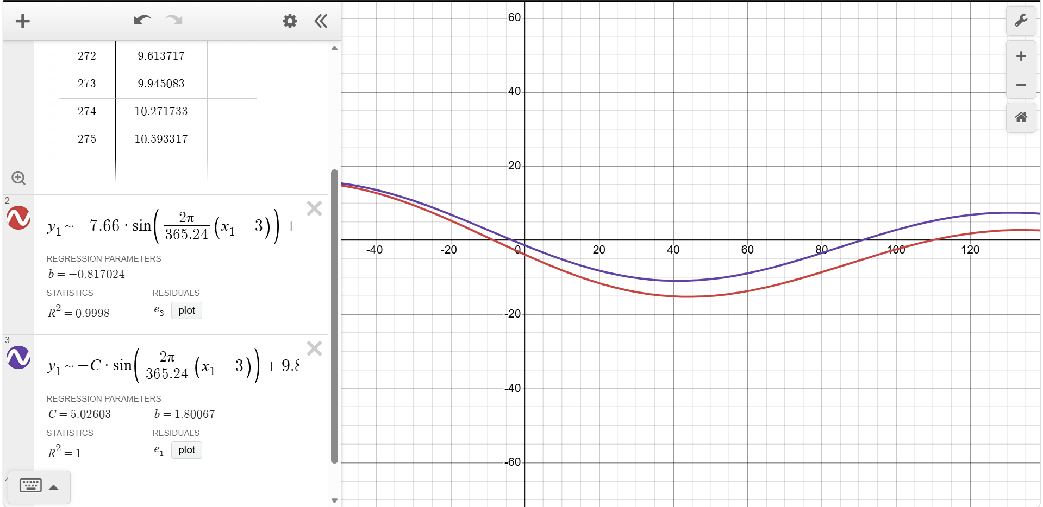
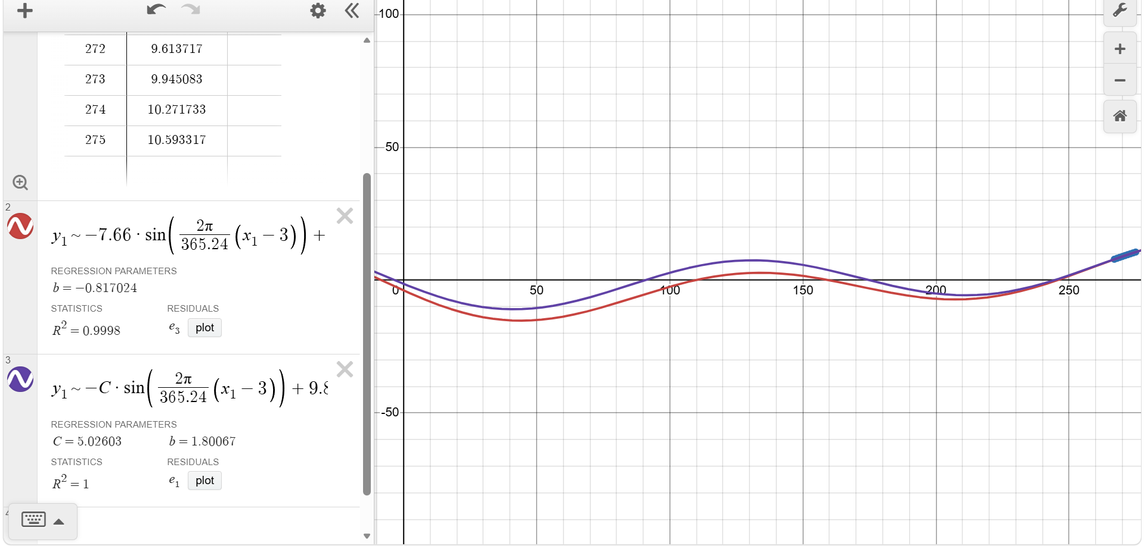
Source – Regressions performed on Desmos, Screenshots taken by the Author
The Red is Original Equation Of Time and Blue is observed Equation of time.

In the bottom left corner of the image attached above (previous page), we got the result that C=5.02603, that is the maximum amplitude for the elliptical component. This Maximum amplitude is in minutes, we need a unitless quantity to maintain the equation with eccentricity (C=2e). Radians is a reliable unit as it is arclength divided by radius, so it’s practically dimensionless. To convert minutes to radians:-
$$C_{rad}=C_{min}∙\frac{2π}{1440}$$
- A full 24-hour solar cycle is 1440 minutes.
- A full geometric cycle is $2π$.
$$C_{rad}=5.02603×0.0043633$$
$$C_{rad}=0.021930076699$$
Now since,
$$C_{rad}=2e$$
$$\frac{0.021930076699}{2}=e$$
$$e=0.01096508345$$
There is a noticeable difference between the two eccentricities because of seven main reasons:-
- Because of approximate extracted data
- The predicted data was sourced from NASA Horizon, its real time data requiring true solar declination while we were approximating it with Cooper’s Equation.
- Because the data were too limited for the application apply regression
- The Variable Fake Meridian (explained later)
- We only extracted less than 2.5% of total observable data in a year, which makes the regression approximate the required eccentricity
- Data here corresponded to consecutive days, since we are near equinox, the data obtained lie in a straight line (i.e. rate of change is nearly constant). So, the regression optimizer cannot “see” the peak of the curve to accurately measure eccentricity. At last, it approximates the peak (C) which could also be the reason for error
- Small errors due to atmospheric refraction and other noises
The regression pipeline recovered e=0.010965 from the combined dataset. Given that only one of the nine data points (24/09/2026) was directly captured by the instrument — with the remaining eight reconstructed from NASA JPL Horizons ephemeris data to validate the derivation and regression methodology (C=2e, unit conversion, Desmos fit) — this result is reported here as confirmation that the extraction pipeline functions correctly, not as an independently derived experimental measurement. The full interpretation of this result, including its limitations and next steps, is discussed in Section 11.
Analytical Note on Azimuth Drift (The Variable Fake Meridian):
In this preliminary proof-of-concept, the initial azimuth offset (3m 31s) was modeled as a first-order local constant. However, as per Mayer’s Formula [$∆t= ∆A×240×\frac{(sin⁡(∅-δ)}{cosδ}$], a fixed horizontal azimuth misalignment interacts with changing solar declination, introducing a secondary drift of 2.6s/day (21s over the 9-day arc). This systematic geometric drift partially accounts for the underestimation of C in the uncorrected regression fit and will be dynamically compensated in the full-scale seasonal dataset.

11.0 CONCLUSION-
Project C.H.I.T.R.A.N demonstrates that the theoretical pathway from ground-level solar telemetry to Earth’s orbital eccentricity, tilt decoupling, the Equation of Centre, and the derived relation C=2e⸻ is mathematically sound and computationally reproducible. The custom-engineered opto-mechanical hardware, built through five major documented iterations of failure and corrections, representing the most significant design constraints encountered; numerous smaller calibration and construction issues were resolved iteratively throughout the build. The build successfully captured a True Solar noon transit timestamp from an urban rooftop, confirming that passive meridian-transit tracking is physically achievable with low cost, non-motorized instrumentation.
Due to severe monsoon cloud cover during the observation window, a full multi-day transit dataset could not be collected within the project timeline. The extraction pipeline was therefore validated against reference ephemeris data from NASA JPL Horizons, confirming that the regression and unit-conversion methodology correctly recovers the accepted eccentricity value when supplied with accurate input. The single instrument-captured observation was compared against this reference and found to be consistent with it, offering a preliminary, though not yet statistically independent, confirmation that C.H.I.T.R.A.N is correctly aligned and functional.
This project’s primary contribution is therefore the validated architecture and methodology for ground-based eccentricity extraction, rather than a fully independent empirical measurement. Full-scale data collection resumes throughout November 2026, targeting a continuous multi-day observation window to obtain an independently derived eccentricity measurement ahead. Beyond this, future work as outlined in Section 8 includes extending observations across multiple geographic stations to further strengthen the dataset’s statistical reliability.

12.0 AI Assistance Disclosure
Generative computational tools were utilized during the development of this project within the following strict parameters:
• Firmware Development: Execution of the compiled C++ firmware running on the Arduino Uno micro-controller—specifically the implementation of the sky-subtraction calibration matrix, the 11-second dead-reckoning metronome interval, and the secure EEPROM data logging sequence—was generated based on architectural logic and functional parameters designed entirely by the author.
• Document Structure: Editorial refinement of structural headings, typographical formatting, and granular phrasing optimization was applied to ensure alignment with standard scientific review criteria.
• Core Integrity: All underlying physical concepts, mathematical derivations, mechanical designs, empirical data collection, and analytical conclusions remain entirely the proprietary work and intellectual property of the author.

13.0 BIBLIOGRAPHY
- Duffie, J. A., & Beckman, W. A. Solar Engineering of Thermal Processes. John Wiley & Sons. (Used for Cooper's Equation and solar declination concepts.)

- United States Naval Observatory. Equation of Time. Retrieved from https://aa.usno.navy.mil/faq/eqtime
- NASA (n.d.) Kepler’s Laws of planetary Motion. Retrieved from https://science.nasa.gov/solar-system/orbits-and-keplers-laws/
- John D. Cook (n.d.) Mean, True and Eccentric Anomalies. Retrieved from https://www.johndcook.com/blog/2022/10/22/orbital-anomalies/
- Time And Date (n.d.). Mean Solar Noon – timeanddate.com
- Arduino Documentation and BH1750 Sensor Documentation for firmware and hardware implementation.
- NASA JPL Horizon Application
- NOAA Solar Calculator

